**SQL Questions and Answers**

Question No. 1:

What will be the result of the query below?

**SELECT** * **FROM** runners **WHERE** id **NOT** **IN** (**SELECT** winner_id **FROM** races)

Explain your answer and also provide an alternative version of this query that will avoid the issue that it exposes.

Answer:

This query retrieves all rows from the "runners" table where the "id" column is not present in the result of the subquery. The main aim here is to find runners who have not won any races.

If the subquery (SELECT winner_id FROM races) contains NULL values in the "winner_id" column, the entire query may not behave as expected. In SQL, when you use NOT IN with a subquery that returns NULL, the result will always be an empty set because comparing with NULL using NOT IN won't return any matches.

To handle NULL values in the subquery and make the query more robust, you can use the NOT EXISTS clause

SELECT * FROM runners r WHERE NOT EXISTS (SELECT 1 FROM races WHERE winner_id = r.id);

**Question: 2**

Given two tables created as follows

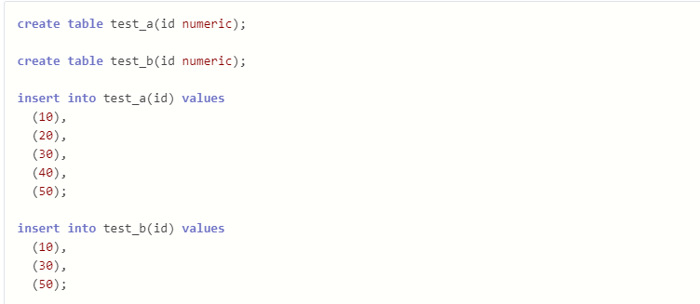

Write a query to fetch values in table test_a that are and not in test_b without using the NOT keyword.

Answer:

SELECT a.id

FROM test_a a

LEFT JOIN test_b b ON a.id = b.id

WHERE b.id IS NULL;

**Question: 3**

Given the following tables:

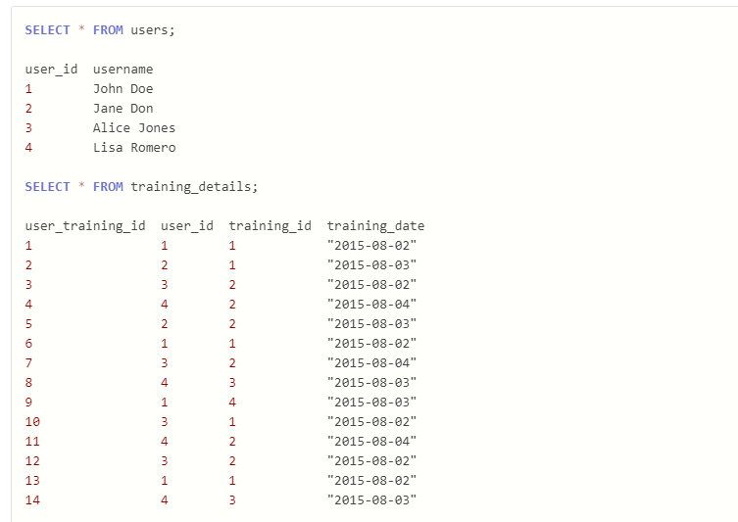

Write a query to to get the list of users who took the a training lesson more than once in the same day, grouped by user and training lesson, each ordered from the most recent lesson date to oldest date.

ANswer:

SELECT

u.user_id,

u.username,

td.training_id,

COUNT(*) AS lesson_count,

MAX(td.training_date) AS most_recent_date

FROM users u

JOIN

training_details td ON u.user_id = td.user_id

GROUP BY

u.user_id, u.username, td.training_id

HAVING

COUNT(*) > 1

ORDER BY

most_recent_date DESC;

This query performs a join between the users and training_details tables, grouping the results by user, training lesson, and then using the HAVING clause to filter for users who took the same training lesson more than once. The results are ordered by the most recent lesson date in descending order.

**Question: 4**

Consider the Employee table below.

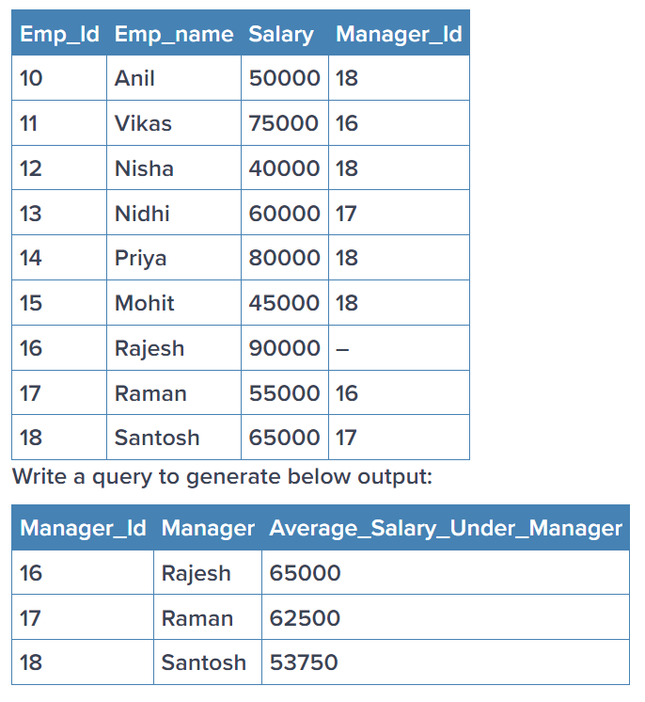

SELECT

manager_id,

Manager,

AVG(Salary) AS Average_salary_under_manager

FROM

employee

WHERE

manager_id IS NOT NULL

GROUP BY

manager_id, Manager

ORDER BY

manager_id;

**Deep Learning QnA**

**Question: 1**

**(a) Explain how you can implement DL in a real-world application.**

**Answer:**

Imagine you have a super-smart robot friend, and you want to teach it to recognize cats and dogs. Deep Learning (DL) is like giving your robot friend a magical pair of glasses that helps it learn on its own. Here's how you can do it:

Get Lots of Pictures: Collect many pictures of cats and dogs to show to your robot friend. The more, the better!

Label the Pictures: Put labels on each picture, saying if it's a cat or a dog. This helps your robot friend know what it's looking at.

Teach with the Magical Glasses: Give the labeled pictures to your robot friend along with the magical glasses (DL model). The glasses learn by themselves to recognize patterns that make cats and dogs different.

Practice, Practice, Practice: Your robot friend needs practice to become a pro. Keep showing it more pictures, and it will get better at telling cats from dogs.

Use in the Real World: Once your robot friend has practiced enough, you can use it to recognize cats and dogs in real life! Just show it a new picture, and it will tell you if it's a cat or a dog.

**(b) What is the use of Activation function in Artificial Neural Networks? What would be the problem if we don't use it in ANN networks.**

These activation functions introduce non-linearities, enabling neural networks to learn and represent complex relationships within the data.

An Activation Function decides whether a neuron should be activated or not. This means that it will decide whether the neuron’s input to the network is important or not in the process of prediction using simpler mathematical operations.

The role of the Activation Function is to derive output from a set of input values fed to a node (or a layer)

If we don't use any activation function in a neural network, the network would essentially be a linear model, regardless of the number of layers. This is because the absence of an activation function means that the output of each neuron is a linear combination of its inputs. Moreover, the hidden layers would be useless and the model will not learn any non-linear relationship in the data. The model will only learn linear relationships that hardly exist in real-world data.